**COURSE OUTCOMES 1**

1.Display future leap years from current year to a final year entered by user.

PROGRAMME CODE:

print(**"______Print Leap Year between two given years_____"**)  
startyear=int(input(**"Enter the Start Year:"**))  
endyear=int(input(**"Enter the End Year:"**))  
for year in range(startyear,endyear):  
 if ((year % 4 == 0) and (year % 100!=0) or (year % 400==0)):  
 print(year)

OUTPUT:

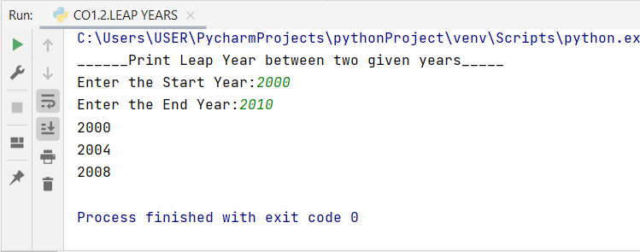

2. List comprehensions:

(a) Generate positive list of numbers from a given list of integers

(b) Square of N numbers

(c) Form a list of vowels selected from a given word

(d) List ordinal value of each element of a word (Hint: use ord() to get ordinal values)

PROGRAMME CODE:

a) list1 = [11, -21, 0, 45, 66, -93]  
*# iterating each number in list*for num in list1:  
 *# checking condition* if num >= 0:  
 print(num, end = **" "**)

OUTPUT:

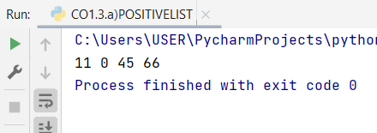

b) print(**"Enter the limit:"**)  
n=int(input())  
squares=[i*i for i in range(n)]  
prin(**"Square of n numbers** \n**"**,squares)

OUTPUT:

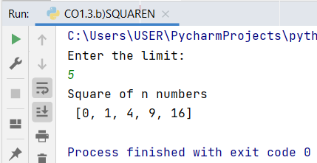

c) word=input(**'Enter your word:'**)  
for letter in word:  
 if letter in **'aeiou'**:  
 print(letter,end=**''**)

OUTPUT:

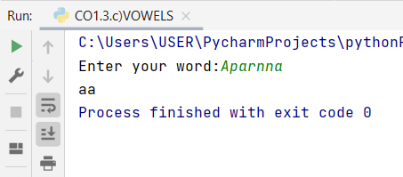

3) Count the occurrences of each word in a line of text.

PROGRAMME CODE:

astr = input(**"Enter the String:**\n**"**)  
char = input(**"Enter the character:**\n**"**)  
print(**"Given String:**\n**"**, astr)  
print(**"Given Character:**\n**"**, char)  
res = 0  
for i in range(len(astr)):  
 if astr[i] == char:  
 res = res + 1  
print(**"Number of time character is present in string:**\n**"**, res)

OUTPUT:

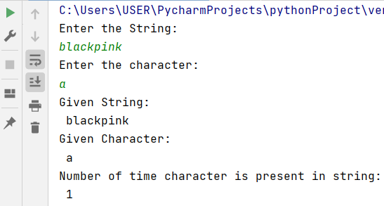

4. Store a list of first names. Count the occurrences of ‘a’ within the list

PROGRAMME CODE:

astr = input(**"Enter the String:**\n**"**)  
char = input(**"Enter the character:**\n**"**)  
print(**"Given String:**\n**"**, astr)  
print(**"Given Character:**\n**"**, char)  
res = 0  
for i in range(len(astr)):  
 if astr[i] == char:  
 res = res + 1  
print(**"Number of time character is present in string:**\n**"**, res)

OUTPUT:

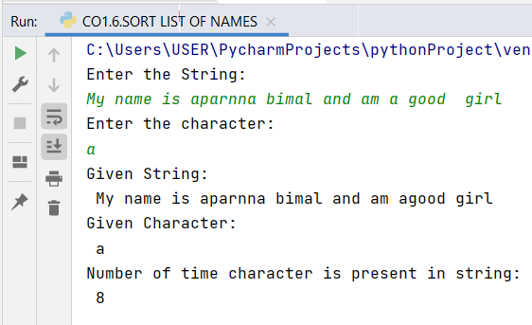

5. Create a string from given string where first and last characters exchanged.

PROGRAMME CODE:  
  
str1=input(**"Enter a String:**\n**"**)  
print(**"String after swapping first and last character:**\n**"**,(str1[-1:]),(str1[1:-1]),(str1[:1]))

OUTPUT:

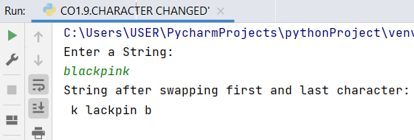

6. Accept the radius from user and find area of circle.

PROGRAMME CODE:

import math  
  
r = int(input(**"Enter the Radius:** \n**"**))  
a = r * r *(math.pi)  
print(**"Area of the Circle is:** \n**"**,a)

OUTPUT:

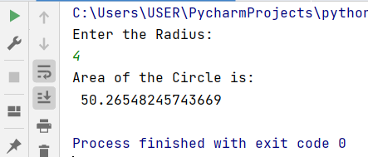

7. Find biggest of 3 numbers entered.

PROGRAMME CODE:  
a = float(input(**"Enter The First Number:**\n**"**))  
b = float(input(**"Enter the Second Number:**\n**"**))  
c = float(input(**"Enter the Third Number:**\n**"**))  
  
c = max(a, b, c)  
print(**"Greatest Among Three Numbers: "**, c)

OUTPUT:

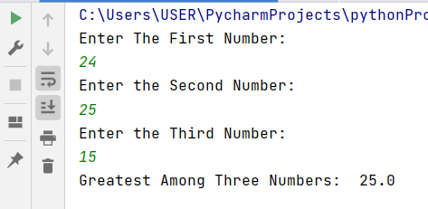

8. Accept a file name from user and print extension of that.

PROGRAMME CODE:

a = float(input(**"Enter The First Number:**\n**"**))  
b = float(input(**"Enter the Second Number:**\n**"**))  
c = float(input(**"Enter the Third Number:**\n**"**))  
  
c = max(a, b, c)  
print(**"Greatest Among Three Numbers: "**, c)

OUTPUT:



9. Create a list of colors from comma-separated color names entered by user. Display first and last colors.

PROGRAMME CODE:

a = input(**"Input the element:**\n**"**)  
f_ext=a.split(**"."**)  
print(**"the extension of the file is :"** +repr(f_ext[-1]))

OUTPUT:

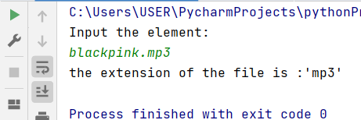

10. Accept an integer n and compute n+nn+nnn

PROGRAMME CODE:  
a=int(input(**"Enter a Number:**\n**"**))  
  
n1 = int(**"%s"** % a)  
n2 = int(**"%s%s"** % (a, a))  
n3 = int(**"%s%s%s"** % (a, a, a))  
  
print(n1, **" "**, n2, **" "**, n3)  
print(**"SUM="**, (n1 + n2 + n3))

OUTPUT:

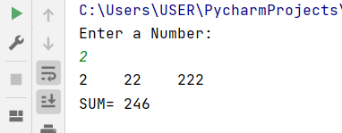

11. Print out all colors from color-list1 not contained in color-list2.

PROGRAMME CODE:

colorlist1 = set([**"White"**, **"Black"**, **"Red"**])  
colorlist2 = set([**"Red"**, **"Green"**])  
  
print(colorlist1.difference(colorlist2))

OUTPUT:

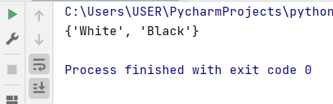

12. Create a single string separated with space from two strings by swapping the character at position 1.

PROGRAMME CODE:

a = input(**"Enter the value:**\n**"**)  
b = input(**"Enter the another value:**\n**"**)  
x = a[0:2]  
a = a.replace(a[0:2], b[0:2])  
b = b.replace(b[0:2], x)  
print(a, b)

OUTPUT:

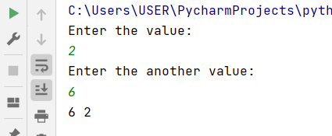

13. Sort dictionary in ascending and descending order.

PROGRAMME CODE:

d = {1:2, 3:4, 4:3, 2:1, 0:0}  
print(**'original dictonary : '** ,d)  
sorted_d = sorted(d.items())  
print(**'dictionary in ascending order by value : '**,sorted_d)  
sorted_d = sorted(d.items(),reverse=True)  
print(**'dictionary in descending order by value : '**,sorted_d)

OUTPUT:

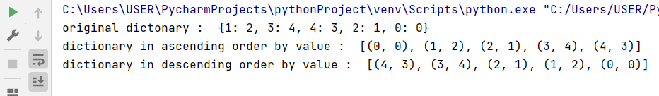

14. Merge two dictionaries.

PROGRAMME CODE:

d1={**'a'**:100,**'b'**:200}  
d2={**'c'**:300,**'d'**:800}  
print(**"Dictionary 1=:"**,d1)  
print(**"Dictionary 2=:"**,d2)  
d=d1.copy()  
d.update(d2)  
print(**"The Merged Dictionary:"**,d)

OUTPUT:

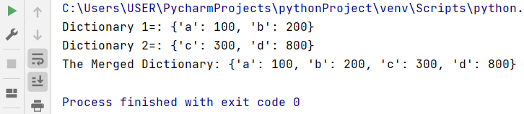

15. Find gcd of 2 numbers.

PROGRAMME CODE:  
a = int(input(**"Enter the First Number:"**))  
b = int(input(**"Enter the Second Number:"**))  
  
for i in range(1, min(a, b) + 1):  
 if a % i == 0 and b % i == 0:  
 gcd = i  
print(**"The Gcd of Given Number is"**, a, **"and"**, b, **"is:"**, gcd)

OUTPUT:

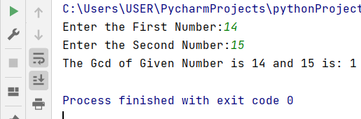

16.From a list of integers, create a list removing even numbers.

PROGRAMME CODE:

num = [7, 8, 120, 25, 44, 87, 987, 555]  
num = [x for x in num if x % 2 != 0]  
print(num)

OUTPUT:

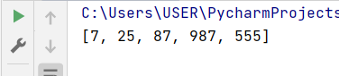

**COURSE OUTCOMES 2**

1. Program to find the factorial of a number

PROGRAMME CODE:

n=int(input(**"Enter the Number:** \n**"**))  
result=1  
  
for i in range(n,0,-1):  
 result = result*i  
print(**"Fatorial of Given Number is : "**, result )

OUTPUT:

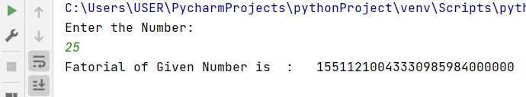

2. Generate Fibonacci series of N terms

PROGRAMME CODE:

n = int(input(**"Enter the Limit:** \n**"**))  
  
a = 0 *#first number*b = 1 *# second number*if n == 1:  
 print(a)  
else:  
 print(b)  
 for i in range(2, n):  
 c = a + b  
 a = b  
 b = c  
 print(c)

OUTPUT:

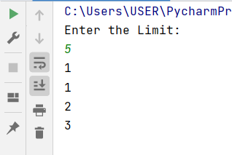

3. Find the sum of all items in a list

PROGRAMME CODE:

list1=[11,5,17,18,23]  
total=sum(list1)  
print(**"SUM OF THE GIVEN LIST IS:**\n**"**,total)

OUTPUT:  
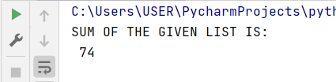

4. Generate a list of four digit numbers in a given range with all their digits even and the number is a perfect square.

PROGRAMME CODE:

import math  
for i in range(1000,10000):  
 num=int(math.sqrt(i))  
 if(num*num==i):  
 n=i  
 while n!=0:  
 r=n%10  
 n=n//10  
 if r%2!=0:break  
 else:print(i)

OUTPUT:

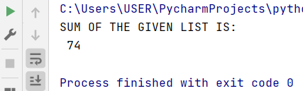

5. Display the given pyramid with step number accepted from user. Eg: N=4

1

2 4

3 6 9

4 8 12 16

PROGRAMME CODE:

rows=5  
for i in range(rows):  
 for j in range(1 , i+1):  
 print(i*j,end=**" "** )  
 print()

OUTPUT:

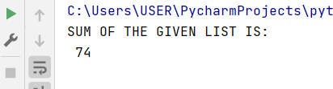

6. Count the number of characters (character frequency) in a string.

PROGRAMME CODE:

from collections import Counter  
  
T = **"MY PYTHON PROGRAMMING"**x = Counter(T)  
print(**"Count of all Characters in :** \n **"**, x)

OUTPUT:



7. Add ‘ing’ at the end of a given string. If it already ends with ‘ing’, then add ‘ly’

PROGRAMME CODE:  
string = input(**"Enter The Word:**\n**"**)  
if len(string) < 3:  
 print(string)  
elif string[-3:] == **'ing'**:  
 print(string + **'ly'**)  
else:  
 print(string + **'ing'**)

OUTPUT:

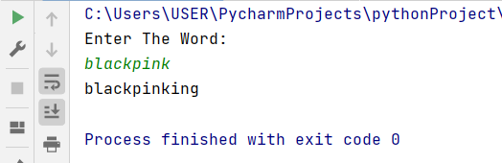

8. Accept a list of words and return length of longest word.

PROGRAMME CODE:

a = []  
n = int(input(**"Enter the Number of element in list:**\n**"**))  
for x in range(0, n):  
 element = input(**"Enter element"** + str(x + 1) + **":"**)  
 a.append(element)  
max1 = len(a[0])  
temp = a[0]  
for i in a:  
 if (len(i) > max1):  
 max1 = len(i)  
 temp = i  
print(**"The Word with the longest length is:"**)  
print(temp)

OUTPUT:  
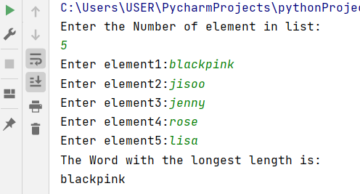

9.Construct following pattern using nested loop

*

* *

* * *

* * * *

* * * * *

* * * *

* * *

* *

*

PROGRAMME CODE:

n = 5  
for i in range(n):  
 for j in range(i):  
 print(**'*'**, end=**" "**)  
 print(**''**)  
  
for i in range(n, 0, -1):  
 for j in range(i):  
 print(**'*'**, end=**" "**)  
 print(**' '**)

OUTPUT:

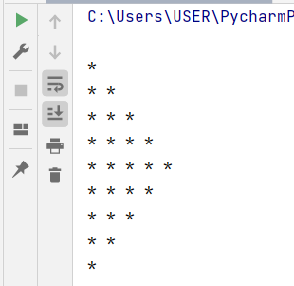

10. Generate all factors of a number.

PROGRAMME CODE:  
def factors(a):  
 for i in range(1, (a + 1)):  
 if a % i == 0:  
 print(i)  
 return;  
  
  
a = int(input(**"Enter a Number :**\n**"**))  
factors(a)

OUTPUT:

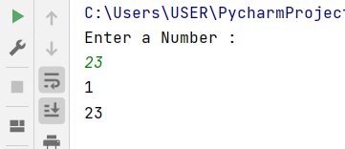

11. Write lambda functions to find area of square, rectangle and triangle.

PROGRAMME CODE:

import math  
  
rectangle_area = lambda l, h : l*h  
circle_area = lambda r: math.pi*r*r  
triangle_area= lambda b,h:0.5*b*h  
  
print(**"Area of Rectangle (30,20) is:"**, rectangle_area(30,20))  
print(**"Area of circle (15) is:"**, circle_area(15))  
print(**"Area of triangle (15) is:"**, triangle_area(15,15))

OUTPUT:

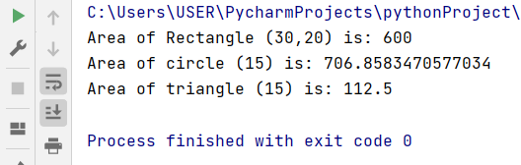

**COURSE OUTCOMES 3**